Introduction to 8051 Microcontroller & Installation of
Software and Hardware Tools


LAB # 01

Spring 2024
CSE-307L Microprocessor Based System Design Lab

Submitted by: Ali Asghar
Registration No.: 21PWCSE2059
Class Section: C

“On my honor, as student of University of Engineering and Technology, I have neither given nor received unauthorized assistance on this academic work.”

Submitted to:
Dr. Asif Ali Khan

Date:
25th February 2024

Department of Computer Systems Engineering
University of Engineering and Technology, Peshawar
Task:
Write assembly and C language code to toggle the led attached with P1 and P2 continuously

Code:
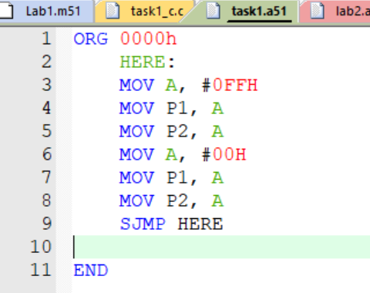
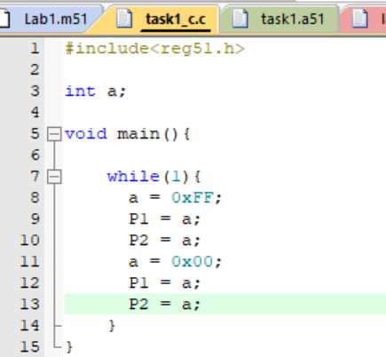
In C
In Assembly

Output:
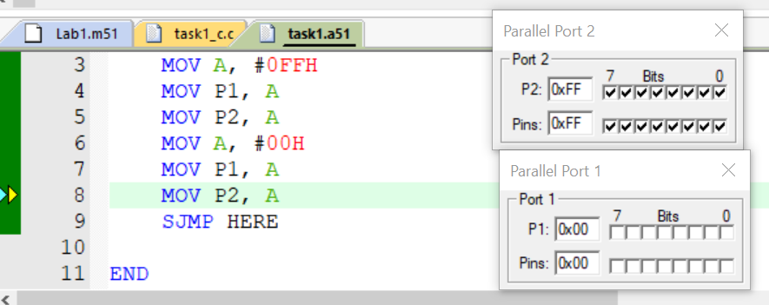
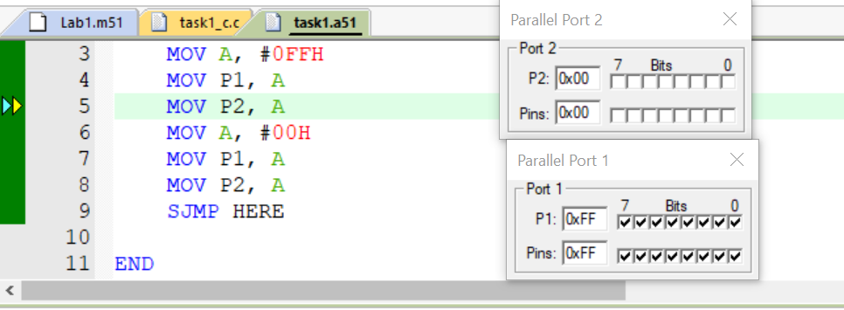

Proteus Simulation:
